Audacity Overview

To open Audacity:

Add a new track:
Tracks > Add New > Audio Tracks
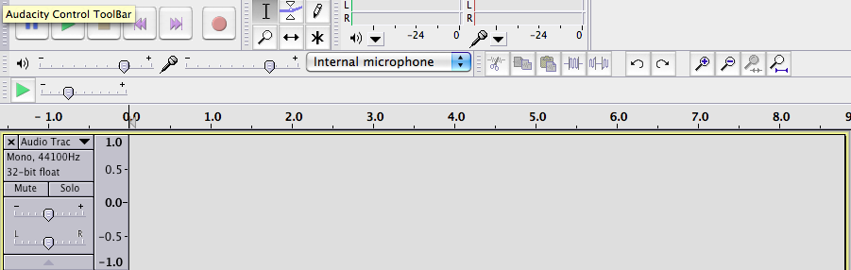

Explanation of tools:
Control Toolbar
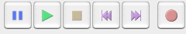 | This VCR like interface controls play, record, pause, skip to front and skip to end of the playhead-where the cursor is in the track – time-wise.

Toolbar Toolbar
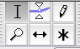 | These 6 icons change the cursor for specific editing functions of audio in a track. The capital I is selection. The two triangles are called envelope and change volume over time. The pencil is the draw tool for modifying audio samples usually at the waveform level. The magnifying glass is the zoom tool for expanding the timeline. The two arrows is timeshift tool for sliding tracks left and right. The asterisk is cursor position multitool-depending on where cursor is it will automatically change.

Mixer and Others
The slider on left is mixer for output levels.

Track

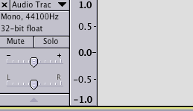 | The pulldown menu allows changes to the track such as name. Mute will mute the track, so other non-muted tracks can be heard. Solo means only this track will be heard. The – and + are gain levels. Think of gain as volume and default position is 0. The L and R are pans

Recording:
Position the cursor where you want recording to begin in the track window. Deault is at the start, however it can be at any point. Press record button. Audacity creates a new track and begins the recording. You will save waveform scrolling right along the track during recording.

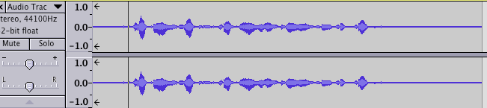

Give the track a new name. Click on Audio Track pull down menu > Name… in subsequent dialog box type in your new name.
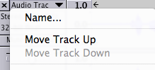

Playback:
Position the cursor at the desired point of playback. Press spacebar. Alternatively select just the audio clip you want to hear, press spacebar.
Selection:
Use cursor “I” tool to select parts of waveform.
Holding down Shift key and using mouse will allow you to select more waveform…cursor will change to hand when you put mouse over the left or right edge of the selection.
View> Zoom will allow closer/farther look at waveform useful for refining selection.

You can also use timecode to be precise.
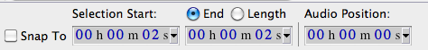

Editing:
Press delete key to remove selected audio.

Cut
By default cutting selection will move the audio waveform to the right of the selection to be adjacent to the beginning of the cut…all audio to the right will shift to the start of the cut.
Split New
If you want to keep the audio to the right of the cut where it is rather than default movement to start of cut point, Edit >Split new will create a new track with the selected audio. Playback will play all tracks as one; unless mute or solo applied.

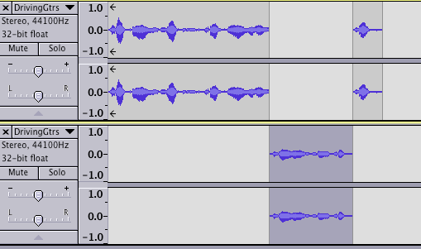

More editing:
The time shift tool can be used to drag audio around and reposition it.
The envelope tool allows you to adjust the amplitude using multiple control points. You could do fades this way, remove a cough or sneeze by lowering the volume for just the sneeze part of the waveform.
Export:
File>Export choose file format based on end use. You will need to know the supported audio file formats from the software that will use to import the file exported out of Audacity. If Audacity will not export a file format required by your software playback, then you will need to convert it to a correct file format.

